Project Progress Report

Extension Wise:

1. Successfully finished the setup of a Chrome Extension
2. UI Features largely finished.
3. Finished testing validity of Frontend code

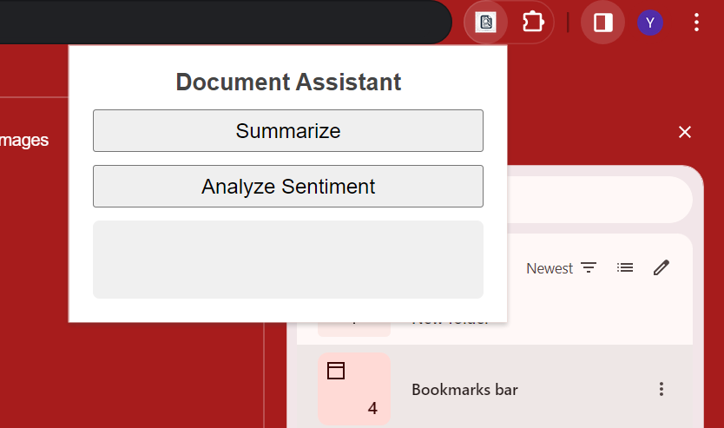’

Algorithm Wise:

1. Data collection and inverted index building (In progress)
2. Text Summarization and Sentiment Analysis (In progress)
3. Integration with ChatGPT API (Not started)